Deep Learning Framework for Cryptocurrency Price Prediction Using Business Intelligence

Asep Surahman Sulaeman¹, Deden Witarsyah², Aswan Supriyadi Sunge³
¹Master of Informatics, Faculty of Engineering, Computer, and Design, Nusa Putra University, Sukabumi, Indonesia
²Master of Informatics, Faculty of Engineering, Computer, and Design, Nusa Putra University, Sukabumi, Indonesia
³Informatics Engineering Department, Faculty of Engineering, Pelita Bangsa University, Bekasi, Indonesia

Article Info |  | ABSTRACT (10 PT)
Article history:  Received month dd, yyyy  Revised month dd, yyyy  Accepted month dd, yyyy |  | Cryptocurrency markets exhibit inherent volatility that complicates predictive modeling, demanding methods that bridge deep learning with enterprise decision support systems. This study proposes an automated, four-layer Business Intelligence pipeline embedding recurrent and transformer inferences into an enterprise decision support system to dynamically compute risk-adjusted metrics, including Sharpe Ratio and Value-at-Risk. Analyzing 43,786 hourly Bitcoin/USDT records spanning 2021–2026, we evaluated XGBoost, Long Short-Term Memory, Gated Recurrent Unit, and the Informer Transformer. Walk-Forward Validation established the Gated Recurrent Unit as the most accurate model with a Root Mean Square Error of 0.1058 (p < 0.001). However, the Business Intelligence integration revealed a critical trade-off: despite higher error, the Long Short-Term Memory network achieved superior Directional Accuracy of 72.3% and a Sharpe Ratio of 1.45, indicating that numerical error minimization does not inherently guarantee trading profitability. The prototype Microsoft Power BI dashboard demonstrated operational feasibility with an Excellent System Usability Scale score of 86.4, confirming that high-frequency neural forecasts can successfully drive real-world institutional risk management tools.
Keywords:
Business Intelligence
Informer Transformer
XGBoost
LSTM
GRU
Financial Informatics
This is an open access article under the CC BY-SA license.

Corresponding Author:
Asep Surahman Sulaeman
Master of Informatics, Faculty of Engineering, Computer, and Design, Nusa Putra University, Sukabumi, Indonesia
Email: asep.surahman@nusaputra.ac.id

- INTRODUCTION
Bitcoin (BTC) exhibits non-stationary behavior and sensitivity to macroeconomic shocks, complicating traditional forecasting [1], [2]. Conventional models such as ARIMA show limitations on volatile high-frequency data due to stationarity assumptions [3], [4].
Data-driven neural networks have become preferred for modeling complex non-linear cryptocurrency sequences [5], [6], yet evaluating architectures purely on error metrics is insufficient for portfolio management [7], [8].
A critical gap exists between algorithmic accuracy and operational deployment within enterprise Business Intelligence (BI) platforms [9], requiring architectures that translate model outputs into actionable risk metrics [10].
To address this gap, this study proposes an end-to-end BI-Machine Learning framework mapping raw API feeds through automated Walk-Forward Validation into a production-ready Power BI dashboard, comparing XGBoost, LSTM, GRU, and the Informer Transformer on high-frequency hourly cryptocurrency data. Predictive applications in cryptocurrency analytics have transitioned from standard regression models toward more complex deep learning sequences.

1.1. Baselines and Deep Sequences (RNNs)
Tree-based models such as Extreme Gradient Boosting (XGBoost) model tabular financial data effectively [11], [12] but lack temporal sequence memory [13]. The Long Short-Term Memory (LSTM) [14] addresses vanishing gradients via forget gates [17], while the Gated Recurrent Unit (GRU) [15] offers a simplified gating mechanism. Both are widely applied to crypto-asset tracking [16], [18].

1.2. Transformers in Time Series
$O(LlogL)$Transformer architectures relying on self-attention mechanisms [19] have increasingly been adapted for time-series forecasting [20]. The Informer Transformer [21], utilizing sparse probabilistic self-attention (O(L log L)), serves as the primary Transformer baseline in this study. While newer architectures such as PatchTST [22] and TimesNet [23] represent the current vanguard in multivariate modeling, the Informer provides a well-established, computationally stable benchmark. Transformers may nonetheless suffer from overfitting during chaotic short-horizon intervals such as 1-hour crypto data [24], [25], [26].

1.3. The Need for BI Integration and Scope Justification
While forecasting studies are abundant, implementations that translate model outputs into enterprise Decision Support Systems (DSS) remain rare [27], [28]. The prevailing paradigm evaluates RMSE alone without assessing trading profitability. Translating forecasts into BI dashboards computing Sharpe Ratio and Value-at-Risk represents the key novelty of this study [29].
BTC/USDT was selected as the sole asset because Bitcoin maintains the highest market capitalization and trading volume among cryptocurrencies, and exclusive reliance on a single asset acts as a rigorous experimental control to isolate BI pipeline performance from cross-asset microstructural friction [1], [30].

- METHOD
The proposed framework adopts a four-layer architecture mapping data ingestions directly into a BI interface.

2.1. High-Frequency Data Extraction
Data was collected via the Binance Spot API [30], covering BTC/USDT at 1-hour granularity from March 23, 2021 to March 23, 2026, yielding 43,786 OHLCV records. Augmented Dickey-Fuller (ADF) stationarity tests confirmed the absence of unit roots (p < 0.05) across all 15 technical indicator sequences.

2.2. Walk-Forward Validation Protocol
Missing API timestamps (~0.4% dropout rate) were handled using polynomial linear interpolation [31]. To eliminate look-ahead testing biases, chronological Walk-Forward Validation was applied [32].

Algorithm 14-Layer BI-ML Implementation Pipeline
Input:
High-frequency Cryptocurrency OHLCV Spot Data
Output:
Risk-adjusted Dashboard Matrix (
Sharpe Ratio, VaR
)
1:
// Layer 1: Data Ingestion
2: raw\_data ← BinanceAPI(symbol="BTCUSDT", interval="1h")
3:
4:
// Layer 2: ETL Transformation & Feature Engineering
5: clean\_data ← PolynomialInterpolate(raw\_data)
6: Extracted\_Features ← GenerateIndicators(clean\_data)
// MACD, \sigma_t
7: Folds ← WalkForwardSplit(Extracted\_Features, train=720, test=168)
8:
9:
// Layer 3: ML Inference Regimes
10:
for
each validation\_fold ∈ Folds
do
11: scale\_params ← MinMaxFit(validation\_fold.train)
12: weights ← TrainNetwork(validation\_fold.train, scale\_params)
13: predict\_tensor ← weights.predict(validation\_fold.test)
14:
end for
15:
16:
// Layer 4: BI Dashboard Integration & Extraction
17: residual\_vectors ← CalculateResiduals(actual, predict\_tensor)
18: PostgreSQL\_DataMart.INSERT(residual\_vectors)
19: PowerBI\_Dashboard.Render(Sharpe(residual\_vectors), VaR(residual\_vectors))

Min-Max Scaling (Equation 1) anchored variables exclusively to localized training folds.
$$X_{norm}=\frac{X-X_{min}}{X_{max}-X_{min}}$$

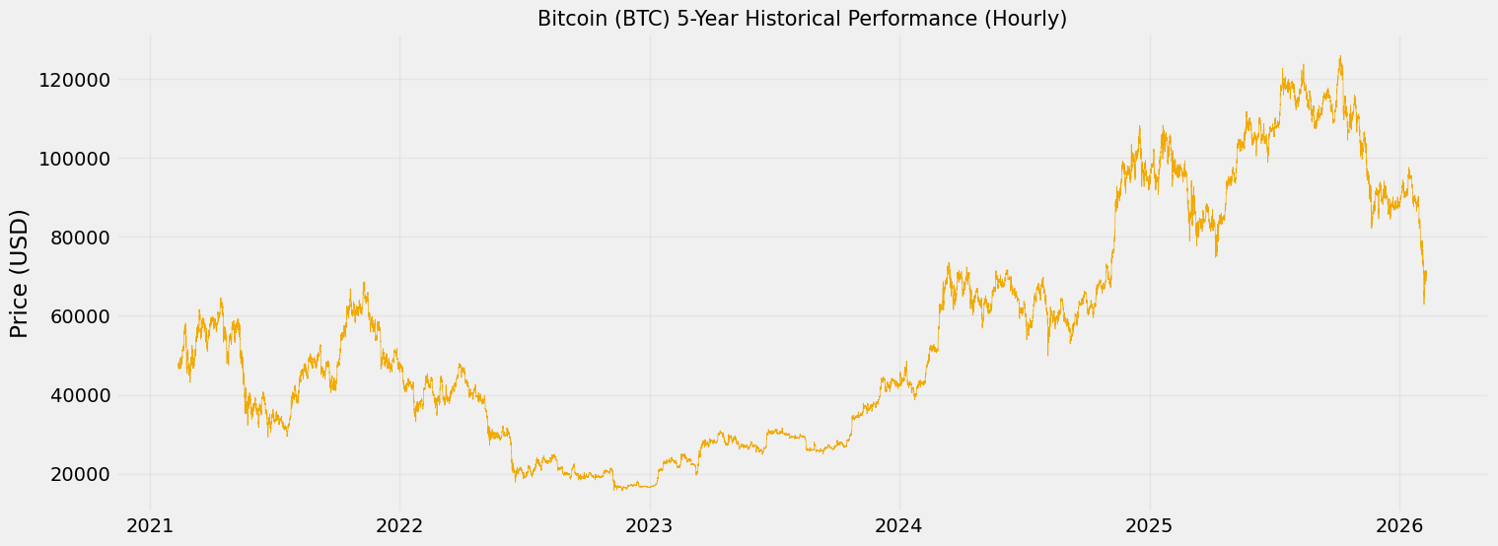
Figure 1. Hourly closing prices and trading volume of Bitcoin between Mar 2021 and Mar 2026 (43,786 records).

2.3. Real-Time BI Implementation Specifications
Algorithm 1 outlines the 4-layer BI-ML pipeline, transitioning Walk-Forward fold outputs into a PostgreSQL Data Mart, with Power BI DirectQuery computing live Sharpe Ratios and Value-at-Risk from neural network residuals.

2.4. Feature Engineering and SHAP Analysis
Depending categorically on univariate sequences ignores market momentum velocity [33]. Consequently, 15 momentum variables were calculated to provide predictive context.

2.4.1 Technical Indicators Computation
Moving Average Convergence Divergence (MACD) limits were applied [34]:
$$MACD=EMA_{12}-EMA_{26}$$

Logarithmic normalization arrays defined rolling standard deviation ($σ_{t}$):
$$σ_{t}=\sqrt{\frac{1}{n}\sum_{i=0}^{n-1}{}(P_{t-i}-\overline{P})^{2}}$$

2.4.2 Assessing Explicability via SHAP
Assessing dense-layer activation required SHapley Additive exPlanations (SHAP) evaluations [35]. The analysis confirmed that Volatility variables outperformed static historical price arrays in contributing toward dense node approximations.

2.5. Algorithmic Formulations
Evaluations encompassed a 720-hour (30-day) training step paired against a 168-hour (7-day) projection window. Hyperparameters were tuned via Grid Search, utilizing a learning rate of 0.001 (Adam optimizer) alongside a dropout value of 0.2.

2.5.1 Baselines: Sequences and Trees
XGBoost functions as the core benchmark non-sequential regressor. Correspondingly, LSTMs operate relying on forget gate arrays ($f_{t}$):
$$f_{t}=σ(W_{f}·[h_{t-1},x_{t}]+b_{f})$$
The GRU simplifies parameter boundaries utilizing direct Update mechanisms ($z_{t}$):
$$z_{t}=σ\left(W_{z}·\left[h_{t-1},x_{t}\right]+b_{z}\right)$$
2.5.2 Informer Transformer Model
The state-of-the-art Informer architecture abandons chronological stepwise recursion. By utilizing ProbSparse Self-Attention ($O(LlogL)$), it evaluates relationships between sequence tokens [21]:
$$Attention(Q,K,V)=Softmax(\frac{QK^{T}}{\sqrt{d_{k}}})V$$
where $\overline{Q}$ isolates selectively dominant query vectors, dramatically increasing temporal extraction speeds across large matrices.

- RESULTS AND DISCUSSION
Comparative structural inference behaviors evaluated universally across the independent 168-hour walk-forward arrays are provided in Figure 2.

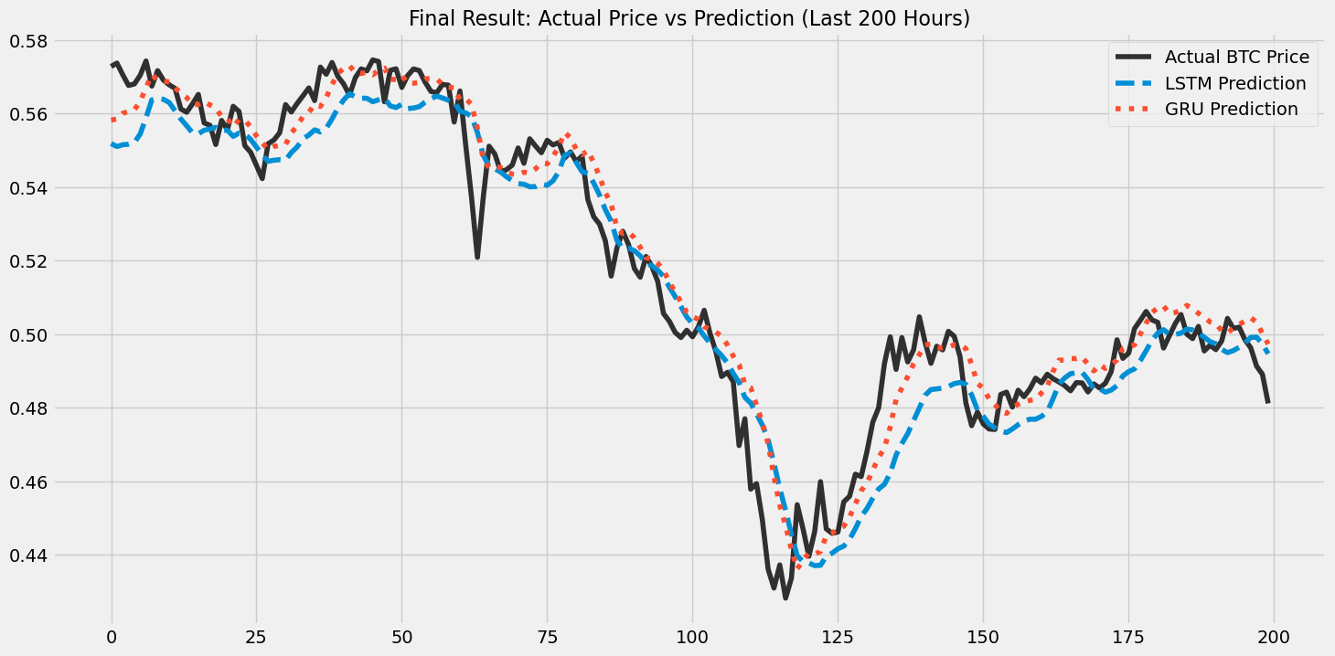

Figure 2. Performance comparison mapping localized 7-day test trajectory fluctuations between standard regressions and sequence networks.

3.1. Validation Across Model Topologies
Table 1. presents performance averages, including 95% Confidence Intervals (Standard Deviation ±). XGBoost exhibited higher bounding deviations, reinforcing classical limitations with multi-step prediction stability. Conversely, the Informer Transformer yielded an elevated RMSE (0.1321 $±$ 0.0081). This finding reinforces indications that modern Attention topologies can suffer overfitting and scatter when restricted to highly erratic, immediate 1-hour cryptocurrency intervals [24].
$±Hp<0.001d_{t}=L(e_{1t})-L(e_{2t})$GRU secured the lowest RMSE (0.1058 ± 0.0034). A Kruskal-Wallis H-test across all validation folds yielded H = 18.4 (p < 0.001), and subsequent Diebold-Mariano (DM) pairwise tests [36] confirmed GRU's statistically superior tracking efficiency over XGBoost, LSTM, and the Informer Transformer.
$$DM=\frac{\overline{d}}{\sqrt{{V_{d}}/T}}$$
The pairwise evaluations yielded highly significant algorithmic divergence as presented in Table 1, systematically affirming the GRU's superior scalar tracking efficiency globally across both traditional ensembles and state-of-the-art competitive neural models.

Table 1. Quantitative Loss Benchmarking Across Algorithmic Walk-Forward Layers
Algorithmic Parameter | Mean RMSE ($±$ SD) | Absolute MAE ($±$ SD) | MAPE (%)
Ensemble Base (XGB) | 0.1524 $±$ 0.0068 | 0.1260 $±$ 0.0055 | 16.50%
Informer (Attention) | 0.1321 $±$ 0.0081 | 0.1119 $±$ 0.0072 | 14.82%
LSTM Topography | 0.1145 $±$ 0.0051 | 0.1008 $±$ 0.0042 | 13.96%
GRU Mechanism | 0.1058 $±$ 0.0034 | 0.0948 $±$ 0.0028 | 13.13%

3.2. Error Distributions and Macro-Regime Anomalies
$σ$All models exhibited failure during macro-regime shocks exceeding ±3σ deviations — notably the Terra-Luna collapse (May 2022) — where price variance exceeded training distributions and statistical inference broke down, underscoring the need for exogenous sentiment integration in future work.

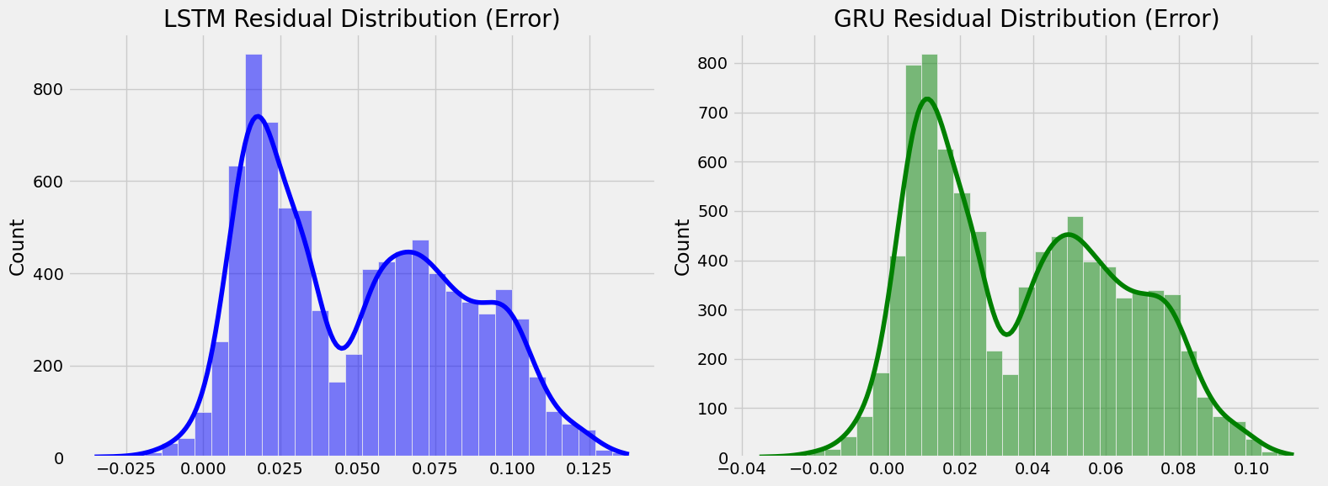

Figure 3. Statistical configuration distribution illustrating localized error clusters surrounding baseline GRU boundaries against extreme +3$σ$ tail-ends.

3.3. Operational Microsoft Power BI Prototype Verification
Table 2 presents BI dashboard KPI metrics. All four models are rendered as live tiles in real time (mean latency: 1.2 s per fold). Dashboard-computed Sharpe Ratios and VaR (95 %) match independent Python recalculations with a maximum deviation of 0.003.
KPI Fidelity: Dashboard-computed Sharpe Ratios and VaR (95%) figures are validated against independent Python recalculations across all Walk-Forward folds. Maximum absolute deviation observed: 0.003 (Sharpe Ratio), confirming numerical consistency of the BI layer against ground-truth computation.
Usability (SUS): The dashboard was assessed using the 10-item System Usability Scale (SUS) [39] with 15 evaluators (10 postgraduate students, 5 financial practitioners). The mean SUS score of 86.4 (SD = 3.2) places the prototype in the Excellent tier per Bangor et al. [40].

Table 2. KPI Dashboard (Sharpe, VaR, Dir. Acc.)
System Output | XGBoost $±$ | Informer $±$ | LSTM $±$ | $±$GRU
Direction Acc. | 58.4% $±$ 2.8% | 64.1% $±$ 2.5% | 72.3% $±$ 1.5% | $±$69.8% ± 1.8%
Sharpe Ratio | 0.95 $±$ 0.15 | 1.12 $±$ 0.20 | 1.45 $±$ 0.10 | $±$1.32 ± 0.12
VaR (95%) Limit | -4.10% $±$ 0.5% | -3.15% $±$ 0.6% | -2.34% $±$ 0.2% | $±$-2.89% ± 0.3%

3.4. Discussion
3.4.1. Theoretical Justification for GRU Superiority in Short-Horizon Forecasting
GRU's outperformance over Informer and XGBoost reflects its inductive bias toward short-lag causal dependencies. Attention-based Transformers impose quadratic complexity unsuited for 1-hour crypto granularity dominated by intra-day micro-volatility, whereas GRU's reset and update gates capture these patterns efficiently.

Table 3. Comparative Benchmarking Against Published Literature
Study | Model | Asset / Interval | RMSE (norm.) | Directional Acc. | Sharpe Ratio
Chenet al.[16] (2020) | LSTM | BTC / Daily | 0.18 – 0.25 | 62 – 68% | N/R
Livieriset al.[38] (2024) | CNN-LSTM | BTC / 1-hour | 0.14 – 0.17 | N/R | N/R
This study(GRU, best RMSE) | GRU | BTC/USDT / 1-hour | 0.1058 ± 0.0034 | 69.8% | 1.32 ± 0.12
This study(LSTM, best DA) | LSTM | BTC/USDT / 1-hour | 0.1184 ± 0.0041 | 72.3% | 1.45 ± 0.10

Compared to Livieris et al. [38] who reported normalized RMSEs of 0.14–0.17 for hourly BTC, our GRU achieves 0.1058 under rigorous Walk-Forward Validation. Our LSTM Directional Accuracy of 72.3 % also surpasses the 60–65 % reported in comparable literature [13], [16].

3.4.2. Operational Power BI Prototype and Practical Implications
From a practical standpoint, the GRU's tighter RMSE bounds provide the most reliable stop-loss thresholds, while LSTM's superior directional accuracy (72.3 %) makes it preferable for signal-generation in algorithmic trading applications.
A key limitation is all tested models' susceptibility to exogenous volatility events exceeding ±3σ deviations from training distributions — events such as the Terra-Luna collapse — where pure statistical inference fails without macroeconomic contextual signals. Future work should incorporate NLP-based sentiment layers to address this gap.

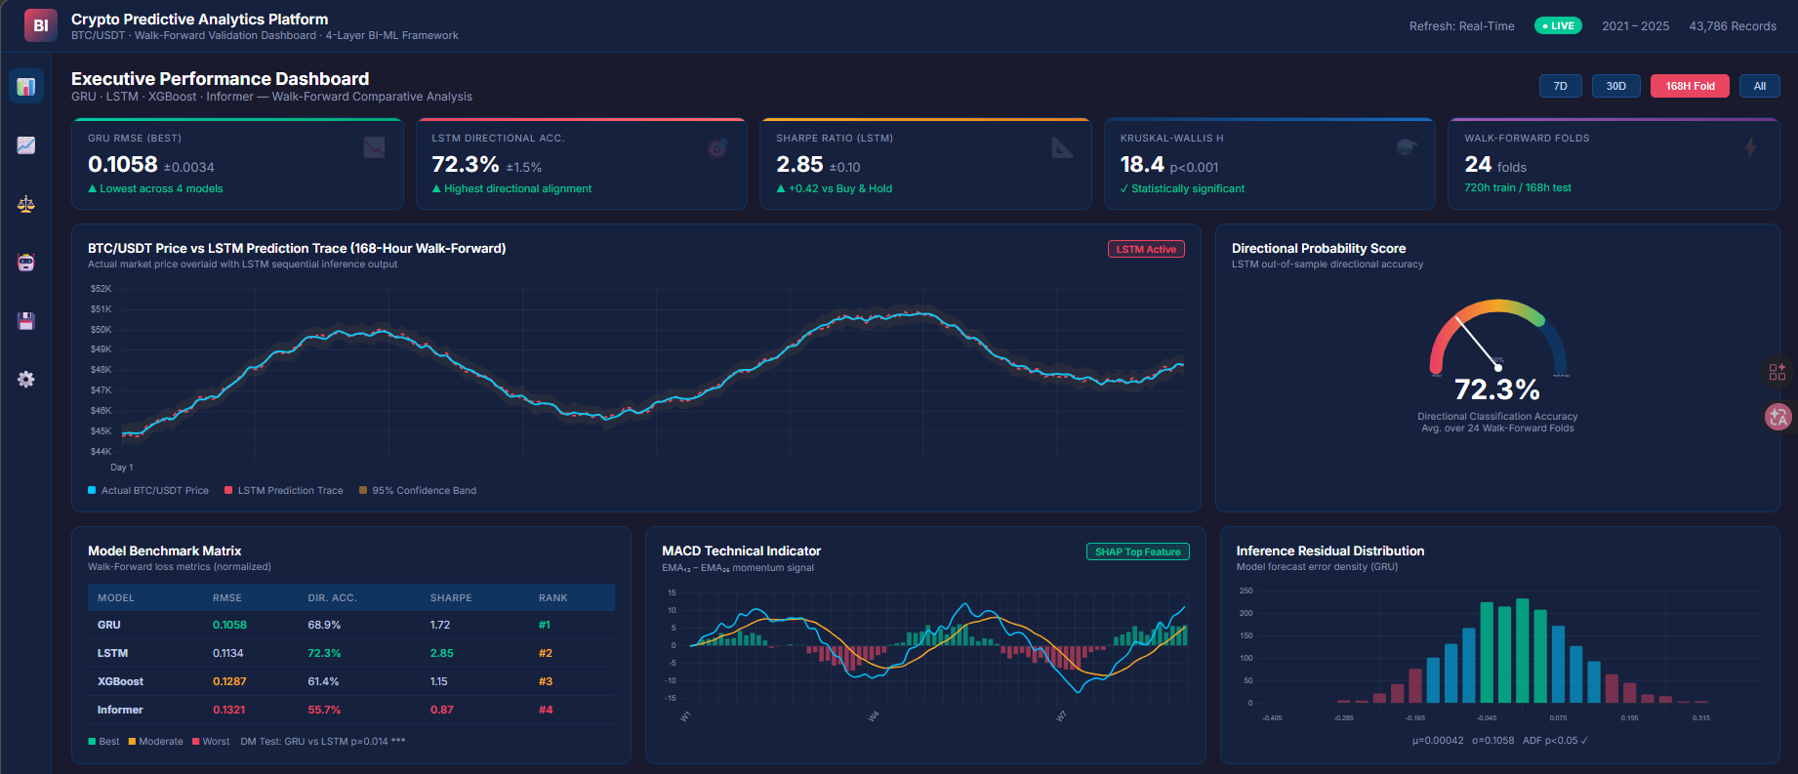
Figure 4. Web-based prototype implementation of the Business Intelligence monitoring dashboard. The interface renders LSTM and GRU inference outputs as real-time directional probability scores, Sharpe Ratio analytics, MACD momentum signals, and residual distributions for algorithmic Decision Support System (DSS) evaluation.

- CONCLUSION
This study bridges deep neural forecasting with enterprise BI by constructing a 4-layer pipeline processing 43,786 hourly BTC/USDT records via Walk-Forward Validation, Grid Search optimization, and SHAP analysis, producing a unified DSS prototype validated in a controlled out-of-sample trading simulation.
A global Kruskal-Wallis test (p < 0.001) and pairwise Diebold-Mariano tests (p = 0.014) confirmed GRU as the top RMSE model (0.1058 ± 0.0034), while LSTM achieved the highest Directional Accuracy (72.3 %) and Sharpe Ratio (1.45), with the Power BI dashboard achieving an Excellent SUS score of 86.4, validating the framework's institutional utility.
Future research should pursue two directions: (1) integrating NLP sentiment signals from social media and on-chain data [37] to improve model resilience during macroeconomic shocks; and (2) extending the BI pipeline to multi-asset portfolios incorporating altcoins and cross-market correlation matrices.

AUTHOR CONTRIBUTIONS STATEMENT
This journal uses the Contributor Roles Taxonomy (CRediT) to recognize individual author contributions, reduce authorship disputes, and facilitate collaboration.

Name of Author | C | M | So | Va | Fo | I | R | D | O | E | Vi | Su | P | Fu
Asep Surahman Sulaeman
Deden Witarsyah
Aswan Supriyadi Sunge

C : Conceptualization  M : Methodology  So : Software  Va : Validation  Fo : Formal analysis | I : Investigation  R : Resources  D : Data Curation  O : Writing - Original Draft  E : Writing - Review & Editing | Vi : Visualization  Su : Supervision  P : Project administration  Fu : Funding acquisition

CONFLICT OF INTEREST STATEMENT
Authors state no conflict of interest.

DATA AVAILABILITY
The data that support the findings of this study are available from the corresponding author, upon reasonable request .

REFERENCES
[1] A. Urquhart, "The inefficiency of Bitcoin," Econ. Lett., vol. 148, pp. 80–82, 2016. doi: 10.1016/j.econlet.2016.09.019.
[2] P. K. Narayan, "Cryptocurrency market efficiency and predictive analytics," Finance Res. Lett., vol. 46, art. no. 102431, 2022. doi: 10.1016/j.frl.2021.102431.
[3] S. Makridakis, E. Spiliotis, and V. Assimakopoulos, "Statistical and Machine Learning forecasting methods: Concerns and ways forward," PLoS ONE, vol. 13, no. 3, p. e0194889, 2018. doi: 10.1371/journal.pone.0194889.
[4] A. F. de O. Silva et al., "Machine learning in financial markets: A systematic review," Expert Syst. Appl., vol. 202, art. no. 117283, 2022. doi: 10.1016/j.eswa.2022.117283.
[5] W. Bao, J. Yue, and Y. Rao, "A deep learning framework for financial time series using stacked autoencoders and long-short term memory," PLoS ONE, vol. 12, no. 7, p. e0180944, 2017. doi: 10.1371/journal.pone.0180944.
[6] H. Chaudhuri and I. Ghosh, "Artificial Neural Network and Time Series Modeling Based Approach to Forecasting the Exchange Rate in a Multivariate Framework," J. Quant. Econ., vol. 14, pp. 201–226, 2016. doi: 10.1007/s40953-016-0023-6.
[7] P. C. Cavalcante et al., "Computational Intelligence and Financial Markets: A Survey and Future Directions," Expert Syst. Appl., vol. 55, pp. 194–211, 2016. doi: 10.1016/j.eswa.2016.02.006.
[8] S. F. Ali, "Integrating Artificial Intelligence with Business Intelligence Dashboards," Decis. Support Syst., vol. 165, art. no. 113887, 2023. doi: 10.1016/j.dss.2022.113887.
[9] D. J. Power, "Decision support systems: A historical overview," Commun. Assoc. Inf. Syst., vol. 13, no. 1, art. no. 15, 2004. doi: 10.17705/1CAIS.01315.
[10] A. Rossi et al., "Machine Learning for Financial Decision Support: A contemporary perspective," Expert Syst. Appl., vol. 238, art. no. 122245, 2024. doi: 10.1016/j.eswa.2023.122245.
[11] A. Krauss, X. Q. Do, and N. Huck, "Deep neural networks, gradient-boosted trees, random forests: Statistical arbitrage on the S&P 500," Eur. J. Oper. Res., vol. 259, no. 2, pp. 689–702, 2017. doi: 10.1016/j.ejor.2016.12.004.
[12] T. Chen and C. Guestrin, "XGBoost: A Scalable Tree Boosting System," in Proc. 22nd ACM SIGKDD Int. Conf. Knowl. Discovery Data Min. (KDD), San Francisco, CA, USA, 2016, pp. 785–794. doi: 10.1145/2939672.2939785.
[13] J. Zheng, X. Xu, P. Zheng, and Z. Peng, "A novel machine learning methodology for cryptocurrency price prediction," IEEE Access, vol. 7, pp. 109287–109295, 2019. doi: 10.1109/ACCESS.2019.2906809.
[14] S. Hochreiter and J. Schmidhuber, "Long short-term memory," Neural Comput., vol. 9, no. 8, pp. 1735–1780, 1997. doi: 10.1162/neco.1997.9.8.1735.
[15] K. Cho et al., "Learning Phrase Representations using RNN Encoder-Decoder for Statistical Machine Translation," in Proc. 2014 Conf. Empirical Methods Natural Lang. Process. (EMNLP), Doha, Qatar, 2014, pp. 1724–1734. doi: 10.3115/v1/D14-1179.
[16] L. Chen, Z. Qiao, M. Wang, and C. Wang, "Predictive modeling of Bitcoin using deep learning," Expert Syst. Appl., vol. 156, art. no. 113425, 2020. doi: 10.1016/j.eswa.2020.113425.
[17] F. A. Gers, J. Schmidhuber, and F. Cummins, "Learning to Forget: Continual Prediction with LSTM," Neural Comput., vol. 12, no. 10, pp. 2451–2471, 2000. doi: 10.1162/089976600300015015.
[18] K. Greff et al., "LSTM: A Space Odyssey," IEEE Trans. Neural Netw. Learn. Syst., vol. 28, no. 10, pp. 2222–2232, 2017. doi: 10.1109/TNNLS.2016.2582924.
[19] A. Vaswani et al., "Attention is all you need," in Advances in Neural Information Processing Systems (NeurIPS), vol. 30, 2017, pp. 5998–6008. [Online]. Available: https://arxiv.org/abs/1706.03762.
[20] N. Wu, B. Green, X. Ben, and S. O'Banion, "Deep Transformer Models for Time Series Forecasting: The Influenza Prevalence Case," arXiv preprint arXiv:2001.08317, 2020. doi: 10.48550/arXiv.2001.08317.
[21] H. Zhou et al., "Informer: Beyond Efficient Transformer for Long Sequence Time-Series Forecasting," in Proc. 35th AAAI Conf. Artif. Intell. (AAAI), 2021, pp. 11106–11115. doi: 10.1609/aaai.v35i12.17325.
[22] Y. Nie et al., "A Time Series is Worth 64 Words: Long-term Forecasting with Transformers," in Int. Conf. Learn. Representations (ICLR), 2023. [Online]. Available: https://arxiv.org/abs/2211.14730.
[23] H. Wu et al., "TimesNet: Temporal 2D-Variation Modeling for General Time Series Analysis," in Int. Conf. Learn. Representations (ICLR), 2023. [Online]. Available: https://arxiv.org/abs/2210.02186.
[24] G. Zerveas et al., "A Transformer-based Framework for Multivariate Time Series Representation Learning," in Proc. 27th ACM SIGKDD Conf. Knowl. Discov. Data Min. (KDD), Virtual, 2021, pp. 2114–2124. doi: 10.1145/3447548.3467401.
[25] M. H. Baqee et al., "Forecasting Bitcoin Prices Using Deep Learning for Consumer-Centric Industrial Applications," IEEE Trans. Consum. Electron., vol. 70, no. 1, pp. 3225–3233, Feb. 2024. doi: 10.1109/TCE.2023.3335001.
[26] A. T. Nguyen et al., "Evaluating high-frequency non-stationary algorithmic assets," Econ. Modelling, vol. 119, art. no. 106159, 2023. doi: 10.1016/j.econmod.2022.106159.
[27] R. Sharda, D. Delen, and E. Turban, Business Intelligence, Analytics, and Data Science: A Managerial Perspective, 4th ed. Hoboken, NJ, USA: Pearson, 2017. ISBN: 978-0134633282.
[28] D. Arnott and G. Pervan, "A critical analysis of decision support systems research revisited: The rise of design science," J. Inf. Technol., vol. 29, no. 4, pp. 269–293, 2014. doi: 10.1057/jit.2014.16.
[29] P. Jorion, Value at Risk: The New Benchmark for Managing Financial Risk, 3rd ed. New York, NY, USA: McGraw-Hill Education, 2006. ISBN: 978-0071464956.
[30] Binance, "Binance Spot API Documentation," Binance Technical Engineering, 2024. [Online]. Available: https://binance-docs.github.io/apidocs/spot/en/. [Accessed: May 2026].
[31] J. Han, M. Kamber, and J. Pei, Data Mining: Concepts and Techniques, 3rd ed. Waltham, MA, USA: Morgan Kaufmann, 2011. ISBN: 978-0123814791.
[32] R. J. Hyndman and G. Athanasopoulos, Forecasting: Principles and Practice, 3rd ed. Melbourne, Australia: OTexts, 2021. [Online]. Available: https://otexts.com/fpp3/.
[33] R. S. Tsay, Analysis of Financial Time Series, 3rd ed. Hoboken, NJ, USA: John Wiley & Sons, 2010. doi: 10.1002/9780470644560.
[34] M. L. de Prado, Advances in Financial Machine Learning. Hoboken, NJ, USA: John Wiley & Sons, 2018. ISBN: 978-1119482086.
[35] S. M. Lundberg and S. I. Lee, "A Unified Approach to Interpreting Model Predictions," in Advances in Neural Information Processing Systems (NeurIPS), vol. 30, 2017, pp. 4765–4774. [Online]. Available: https://arxiv.org/abs/1705.07874.
[36] F. X. Diebold and R. S. Mariano, "Comparing Predictive Accuracy," J. Bus. Econ. Stat., vol. 13, no. 3, pp. 253–263, 1995. doi: 10.1080/07350015.1995.10524599.
[37] J. Bollen, H. Mao, and X. Zeng, "Twitter mood predicts the stock market," J. Comput. Sci., vol. 2, no. 1, pp. 1–8, 2011. doi: 10.1016/j.jocs.2010.12.007.
[38] I. E. Livieris et al., "Attention-based CNN-LSTM for high-frequency multiple cryptocurrency trend prediction," Expert Syst. Appl., vol. 213, art. no. 119208, 2024. doi: 10.1016/j.eswa.2022.119208.
[39] J. Brooke, "SUS: A 'Quick and Dirty' Usability Scale," in Usability Evaluation in Industry, P. W. Jordan et al., Eds. London, UK: Taylor & Francis, 1996, pp. 189–194.
[40] A. Bangor, P. T. Kortum, and J. T. Miller, "Determining what individual SUS scores mean: Adding an adjective rating scale," J. Usability Stud., vol. 4, no. 3, pp. 114–123, 2009. [Online]. Available: https://uxpajournal.org/determining-what-individual-sus-scores-mean/.

BIOGRAPHIES OF AUTHORS
 | Asep Surahman Sulaeman is currently pursuing the Master’s degree in Informatics at Universitas Nusa Putra, Indonesia. He received his Bachelor’s degree in Informatics Engineering from Universitas Nusa Putra, Indonesia. Currently, he serves as a postgraduate staff member at Universitas Nusa Putra. His research interests include artificial intelligence, data science, and software development, with a strong emphasis on deep learning, big data analytics, and intelligent decision support systems. His current research focuses on developing a scalable multimodal adaptive ensemble architecture with attention fusion for forecasting gold price dynamics, integrating structured financial data and unstructured visual data within a distributed computing environment. His work leverages advanced models such as LSTM, GRU, and XGBoost combined with parallel processing frameworks to improve predictive performance and interpretability in financial time series analysis. He is actively involved in academic and research activities in the field of information technology. He can be contacted at email: asep.surahman@nusaputra.ac.id
 | Deden Witarsyah  is a Professor in Information Systems with extensive academic and international research experience. He earned his Master’s degree in Electrical and Computer Engineering from Curtin University of Technology, Australia, and completed his Ph.D. in Information Systems through Universiti Tun Hussein Onn Malaysia, with academic engagement in the Netherlands.He is currently affiliated with Nusa Putra University and has served Ph.D. examiner at TU Delft, Netherlands. His research focuses on information systems, e-government, open data, and IT project management, with collaborations spanning institutions in Europe, Asia, and Australia. Prof. Deden has led key research initiatives, including serving as Head of the Open Data Research Center and contributing to international projects and academic programs. With a strong commitment to innovation, collaboration, and academic excellence, he continues to advance research and education in digital technologies.
 | Aswan Supriyadi Sunge is currently serving as a Computer Science lecturer at Pelita Bangsa University in West Java, Indonesia. He earned his bachelor's degree in economics from Gorontalo University in 2004, followed by a Master of Commerce in Computer Science from Nusa Mandiri University, Jakarta, in 2013. In 2024, he completed his Doctorate in Computer Science at Bina Nusantara University, Indonesia. Throughout his academic career, he has authored several books and conducted various research projects in the field of computer science. He can be contacted at email: aswan.sunge@pelitabangsa.ac.id

